Indian School Al Wadi Al Kabir
SAMPLE PAPER 1 (2023-24)
INFORMATICS PRACTICES (Code: 065)
CLASS : XII Max. Marks:70
Time: 3 hours
General Instructions:
- This question paper contains five sections, Section A to E.
- All questions are compulsory.
- Section A has 18 questions carrying 01 mark each.
- Section B has 07 Very Short Answer type questions carrying 02 marks each.
- Section C has 05 Short Answer type questions carrying 03 marks each.
- Section D has 02 questions carrying 04 marks each.
- Section E has 03 questions carrying 05 marks each.
- All programming questions are to be answered using Python Language only.

 | SECTION A
1. | What is the full form of VOIP?  - Voice Over Interchange Protocol  - Voice Over Internet Protocol  - Voice Over Intranet Protocol  - Voice Over Intelligence Protocol | 1
2. | __________ is a code hidden in a program such as a game or spreadsheet that looks safe to run but has hidden side effects.  a. Virus  b. Trojan horse  c. Worms  d. Bot | 1
3. | Online posting of rumors, giving threats online, posting the victim’s personal  information, comments aimed to publicly ridicule a victim is termed as  a. Cyber bullying  b. Cyber crime  c. Cyber insult  d. All of the above | 1
4. | Which of the following is an aggregate function?  (a) MOD( )  (b) ROUND( )  (c) MIN( )  (d) MONTHNAME( ) | 1
5. | Which of the following function displays the total no. of unique values under the column DEPARTMENT in STAFF table?  SELECT _______FROM STAFF;  (a) SUM(DISTINCT DEPARTMENT)  (b) COUNT(UNIQUE DEPARTMENT)  (c) COUNT(DISTINCT DEPARTMENT)  (d) SUM(UNIQUE DEPARTMENT) | 1
6. | Code of the software will be protected by .  a. copyright  b. patent  c. registered trademark  d. None of the above | 1
7. | Which of the following is a DML command?  (a) DROP  (b) DELETE  (c) DESC  (d) ALTER | 1
8. | Returns a substring of size N starting from the specified position (pos) of the string?  (a) SUBSTR(string, pos, N)  (b) INSTR(string, substring)  (c) MID(string, pos, N)  (d) Both (a) and (c) | 1
9. | Which of the following (a) to (d) will you use in the SQL query to display PROJECTCODE and PROJECTNAME from the table PROJECT in which all the values under the data column ACTIVITY consists of text “LAB” anywhere in its name?  SELECT PROJECTCODE, PROJECTNAME FROM PROJECT WHERE ACTIVITY;  (a) LIKE “LAB”  (b) LIKE “%LAB”  (c) LIKE “%LAB%’’  (d) LIKE “_LAB_” | 1
10. | EApp is a dictionary with the following elements,  {’Photomath’:35,’Simply Piano’:20, ‘Google Classroom’:50, ‘Kahoot’:30, ‘Duolingo’:40}  A series EduApp is created with the above dictionary ‘EApp’. Which  statement given below will produce the following output?  Output:  Simply Piano 20  Google Classroom 50  Kahoot 30  a) print(EduApp.loc[‘Simply Piano’:’Duolingo’])  b) print(EduApp.iloc[1:3])  c) print(EduApp.loc[‘Simply Piano’:’Kahoot’])  d) print(EduApp.iloc[2:5]) | 1
11. | To rename the row indices ‘Emp1’ to ‘Manisha’, ‘Emp2’ to ‘Shreya’, ‘Emp3’ to ‘Roshan’ and ‘Emp4’ to ‘Rakesh’ in a data frame EmpDF, Which of the following statement (a) to (d) will be used? (a)EmpDF=EmpDF.rename({‘Emp1’:’Manisha’, ‘Emp2’: ‘Shreya’, ‘Emp3’: ‘Roshan’, ‘Emp4’: ‘Rakesh’}, axis = ‘index’)  (b) EmpDF=EmpDF.rename({‘Emp1’:’Manihsa’, ‘Emp2’: ‘Shreya’, ‘Emp3’: ‘Roshan’, ‘Emp4’: ‘Rakesh’}, axis = ‘rows’)  (c) EmpDF=EmpDF.rename([‘Emp1’:’Manihsa’, ‘Emp2’: ‘Shreya’, ‘Emp3’: ‘Roshan’, ‘Emp4’: ‘Rakesh’], axis = ‘index’)  (d) None of the above | 1
12. | A dataframe can be created by using Series, List of Dictionaries and Structured ndarray.  a. Incorrect statement  b. Partially correct statement  c. Correct statement  d. None of the above | 1
13. | In this topology, each communicating device is connected with every other device in the network.  a. Star  b. Mesh  c. Bus  d. Tree | 1
14. | Which function is used to display the Name of the day of StockDate column in VENDOR table?  (a) SELECT DAYNAME(STOCKDATE);  (b) SELECT DAY_NAME(STOCKDATE) FROM VENDOR;  (c) SELECT DAYNAME(STOCKDATE) FROM VENDOR;  (d) SELECT DAYOFNAME(STOCKDATE) FROM VENDOR; | 1
15. | ________includes any visual symbol, word, name, design, slogan, label, etc., that distinguishes the brand from other brands.  a. Trademark  b. Patent  c. Copyright  d. None of the above | 1
16. | After practical, Meera left the computer laboratory but forgot to sign off from her email account. Later, her classmate Suja started using the same computer. She is now logged in as Meera. She sends inflammatory email messages to few of her classmates using Meera’s email account. Suja’s activity is an example of which of the following cyber crime?  a. Plagiarism  b. Hacking  c. Identity theft  d. Cyber bullying | 1
17. | Assertion (A): A Switch is a network device that can receive the data, analyze it and transmit to other networks.  Reason (R): Switch is called as an Intelligent hub.  i. Both A and R are true and R is the correct explanation for A  ii. Both A and R are true and R is not the correct explanation for A  iii. A is True but R is False  iv. A is false but R is True | 1
18. | Assertion (A): When using a dictionary to create a DataFrame, keys of the dictionary become the column labels of the DataFrame.  Reason (R): Series can be created from a Dictionary.  i. Both A and R are true and R is the correct explanation for A  ii. Both A and R are true and R is not the correct explanation for A  iii. A is True but R is False  iv. A is false but R is True | 1
 | SECTION B
19. | Expand and define the function of a MODEM. Write any two points.  OR  How to host a website? Write the steps involved to host a website. | 2
20. | Consider the string Message = “Learning is Fun”. Write SQL commands:  - To display the output EARN from the string Message.  - The lower case of last 3 letters of the string Message. | 2
21. | What are the differences between WHERE and HAVING clauses in SQL? Give examples. | 2
22. | Write a program to create the following series object named Seminar using a dictionary SemDict The details are as shown below. Also Write python statements to change the index name as SemTopics and display the series. Note: Sem1, Sem2, Sem3, Sem4 and Sem5 are the indices.  Sem1 Business Intelligence Sem2 Artificial Intelligence Sem3 Corporate Law  Sem4 Communication Technology Sem5 Virtual Reality | 2
23. | Define: Net etiquette. Give any two examples of Social Media etiquettes.  OR  What do you mean by e-waste? Give any two examples of the impact of e- waste on environment. | 2
24. | Write the output of the following code: Given two series SER1 and SER2 SER1 SER2  A 15 C 2  B 25 D 3  C 35 E 4  D 45 F 5  E 55 G 6  F 60 H 8  Find the output for the following python pandas statements (i) and (ii)  - print(SER1 * SER2)  (ii) print(SER1.tail(3)) | 2
25. | Carefully observe the following dataframe BakeryDF  ICode IName Rate  A B001 Tea Cake 275  B B002 Biscuits 75  C B003 Chocolate Cake 350  D B004 Bread 40  E B005 Bun 30  Answer the following:  (i) Write a python statement to change the column name IName to  ItemName.  (ii) Write a python statement to transpose the data frame BakeryDF | 2
 | SECTION C
26. | Predict the output of below given SQL queries  (i) SELECT ROUND(2576.984, -2);  (ii) SELECT POW(INSTR(“INFORMATION FORM”,”RM”), 4);  (iii) SELECT SUBSTR(TRIM(“ VISUAL MEDIA WORLD ”), 8); | 3
27. | Write a program to create a data frame with the help of a dictionary that represents roll no, subject and marks of 4 students and sort the data frame in descending order of their marks and print all the details. | 3
28. | Write MySQL statements for the following:  - To display the list of tables in the database COMPANY .  - Create the table EMPLOYEE as per the following :  Field Name Type Size Constraint  empid Int 4 Primary Key  Name Varchar 20 Not Null  Dept Varchar 20  DOJ date  Salary Int 10 | 1+2
29. | What do you mean by IPR? In what ways Intellectual Properties are protected?  OR  What are the safety measures used to reduce the risk of cybercrime? Write a short note on any one safety measures | 3
30. | Consider the DataFrame ‘CoffeeShopDF’ given below and answer the  questions from (i) to (iii).  Following DataFrame ‘CoffeeShopDF’ containing year-wise sales figures for  five items as row labels and years as column labels.  2018 2019 2020 2021  Chocolates 25000 32000 40000 37000  Ice Creams 18000 21000 24000 22500  Cakes 34000 38900 52000 45700  Rose Milk 12500 17000 24000 16500  Badam Milk 7800 11500 13250 9045  (i) Write a statement to add new row for another Item ‘Chips’ with values 33500, 36400, 72000, 65000.  (ii) Write the code to delete the row at index “Cakes”.  (iii) Write a statement to delete three columns having column labels as  2018, 2019 and 2020. | 3
 | SECTION D
31. | Consider the following data frame of automobile  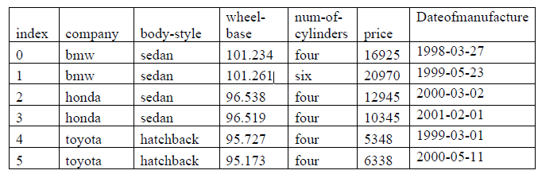  Write SQL queries using SQL functions to perform the following operations:  - a) Display company name and body wheel base after rounding off to nearest ten’s decimal places.  - b) Display the position of occurrence of the string “dan” in body style.  - c) Display the 3 characters from company name starting from second character.  - d) Display the year of manufacturing for sedan; | 4
32. | Consider the following Data Frame ProjectDF.  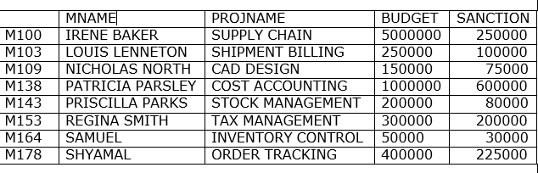  - Predict the output of the following python statements:  - ProjectDF[‘PROJNAME’]  - ProjectDF.loc[‘M138’: ‘M164’]  - Predict the output of the following python statement: ProjectDF.iloc[2:5,[0,2]]  OR (Option for part (B) only)  Write a Python statement to compute and display the BudgetBalance  (BUDGET – SANCTION) for the above given DataFrame. | 2+1+1
 | SECTION E
33. | Write suitable SQL query for the following:  i. Display 3 characters starting from 3rd character in the string ‘all are welcome’.  ii. Display the string ‘informatics practices’ in upper case.  iii. Round off the value 143823.778 to 2 decimal places to the left of decimal.  iv. Display 125 raised to the power 2.  v. Remove the spaces from both ends of the values present in the column first_name of the table class.  OR  Explain the following SQL functions using a sample query each.  i. LOWER()  ii. LTRIM()  iii. MOD()  iv. SYSDATE()  v. SQRT() | 5
34. | Evolving World Centre is a charitable trust responsible for providing yoga and meditation training to young and old persons for helping the society to have good health and also spreading peace in the society. The center is planning to make full use of technology tools and modern gadgets in the center for 100% utilization of the resources. The center has four different wings spread out in large area. The physical distances between these wings and the number of computer systems to be installed in these wings are given as follows. You as a network expert have to answer the queries as raised by their administrators in (a) to (e).  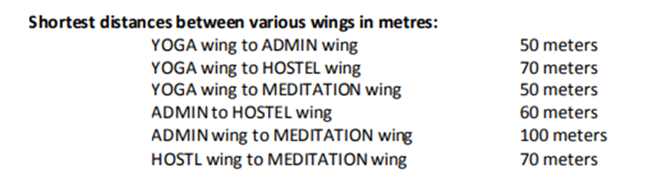  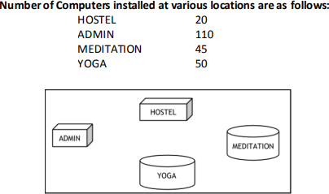  - Suggest the most suitable wing out of the four to install the main server of this center to get efficient Connectivity.  - Suggest by drawing the best cable layout for effective network connectivity of all the wings of this center.  - Suggest the suitable place to install the repeater in the network and also the kind of network will be formed with this network (PAN / LAN / MAN / WAN).  - Suggest, which device will be best suited for connecting multiple computer systems installed in each of the wings out of the following:  MODEM / Switch / Gateway / Router  - Suggest best communication medium among the following to provide most efficient and fastest connectivity between the various wings. The company/trust is ready to compromise the cost for this network setup.  Co-axial cable, Ethernet Cable, Optical Fiber, Single pair Telephone Cable | 5
35. | Write a python program to plot a line chart based on the Currency values in US Dollar to Indian Rupees in 5 different years. Give proper labelling for X-axis, Y-axis and title for the line chart. Also write a statement to save the line chart as “Currency.png” and display it.  Year=[2018,2019,2020,2021,2022] USD=[65,75,70,75,80]  OR  Mrs. Johana is working in Bharat Electronics Limited, a leading Showroom in Kanpur. She wants to create a bar graph to compare the price list of all the AC brands available in the showroom. Help her by writing a code to plot this graph with chart title, x-axis title and y-axis title. Also give suitable python statement to save this chart.  Write Python code to plot a bar chart for India’s medal tally as shown  below:  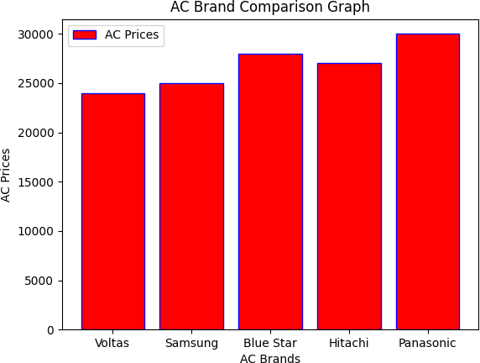 | 5

